Wellness Lesson 2

Special April Fool’s Day edition! :D

Corresponding video: The power of laughter <https://www.youtube.com/watch?v=9WzVMZunzaM>

**Activities:**

* Like the video, says Laughter is contagious. Just Laugh!!!
* Talk about some of the funniest experiences you have had.
* Remind children about things they say or do that make you smile and laugh.
* Ask your kids what they find funny and why?
* Maybe even talk about some April Fool’s day fun you have had….here are some “fruity” jokes to help if nothing else comes to mind.

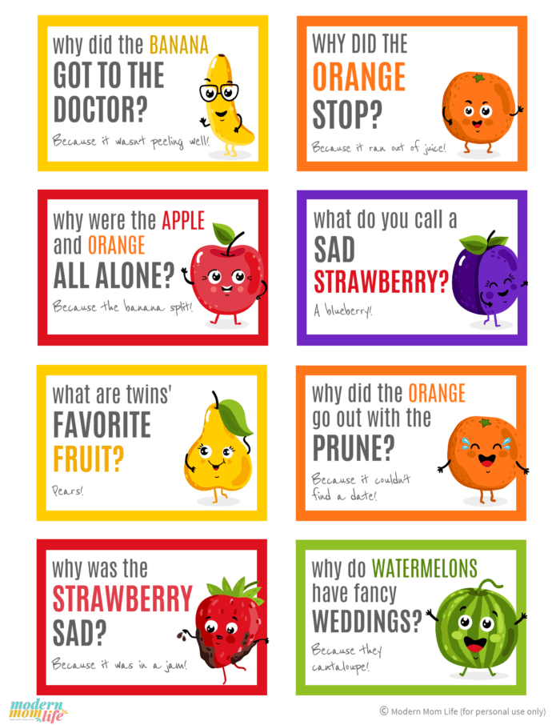

**Challenges for families**:

* During this time of stress and overwhelming uncertainty, please remember to take a moment to share some moments of joy with one another. It really can make all the difference.
* Share some of your funny family stories with us, silly faces, jokes and silliness. We want to hear from you!!! Find us on Facebook: Lake Shore Family Support Center or Twitter @LSFamilySupport ☺